The struggle of a physically challenged poor village youth
Murugan, 27 years old youth of Devarkulam village in Tirunelveli district of Tamil Nadu, India is crippled in both legs and he can only crawl. The youth has 3 sisters and one younger brother, who were all married and settled elsewhere. They were all originally living in Bombay, but after the death of his father 15 years back, the family shifted to their native village and started living in a Government-provided small group house. With someone’s help, he opened a small shop in the village 7 years back for the family’s sustenance, but it had to be closed after some months. His mother started working as a help in a small hotel at distant Tirunelveli town, on a wage of Rs.250 per day, from which she has to spend Rs. 70 for her to and fro bus trip.
The youth was identified by the field staff of SIVA Trust to be an enthusiastic youngster and the Trust decided to help him with financial assistance of Rs.20,000 to re-start his small shop and replenish with fresh goods for sale, after getting assurance from the villagers to help the youth and his family come out of their poverty. The shop was formally inaugurated on December 3rd, 2018, the International Day of Disabled. In the last one fortnight, Murugan had earned Rs.2,000 by way of profit, which has definitely made a marked change in the income of the family.

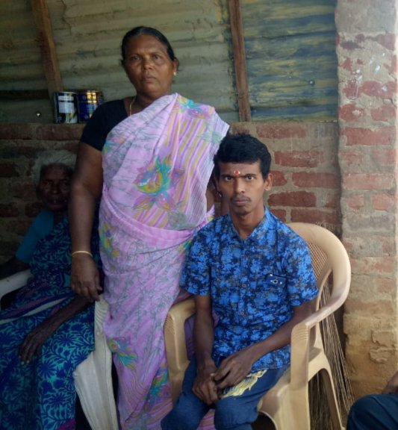
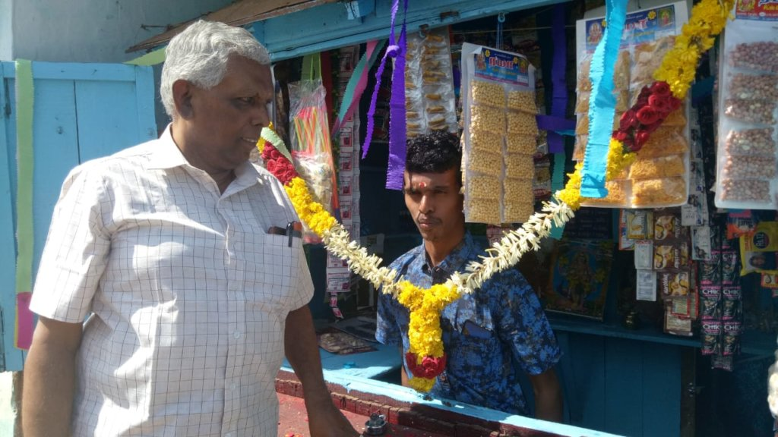
The Trust has also approached the District Differently-abled Rehabilitation Officer to provide him with a three-wheeled scooter from Government resources, as early as possible, so that Murugan’s mobility will improve and he can go on his own to procure more saleable things including fresh vegetables, for his small shop. Once that gets through, his earnings will be more and he can independently move around.

