SIVA Trust activities report of TdH-NL program for the first quarter of 2019
SHG members training:
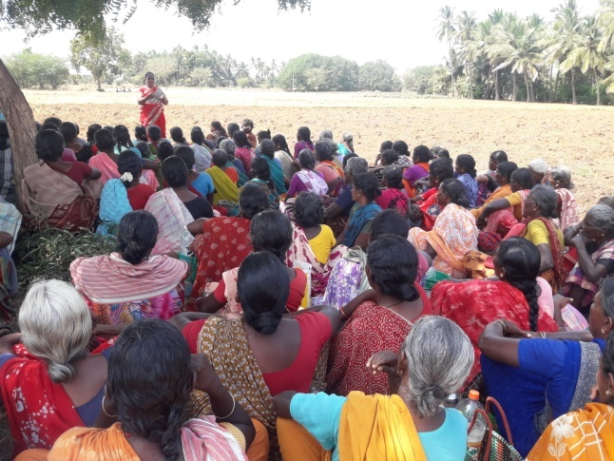
Regular training were conducted at 3 centres in January (229 members), 4 centres (340) in February and 4 centres (398) in March, in which Community Organisers Hemima, Umabathy and Pramachi trained the members on gender equality, self respect, problem solving, decision making and handling stress and emotions. They also explained the activities of SIVA Trust and appealed the members to stop child abuse, child marriage and Child labour. Focus was made on child protection, welfare of differently abled, prevention of child marriage and clean village campaign. They were also told to avail the vocational training facilities in computer and tailoring provided by SIVA Trust to improve the skill of their wards.
Supplementary Centres:
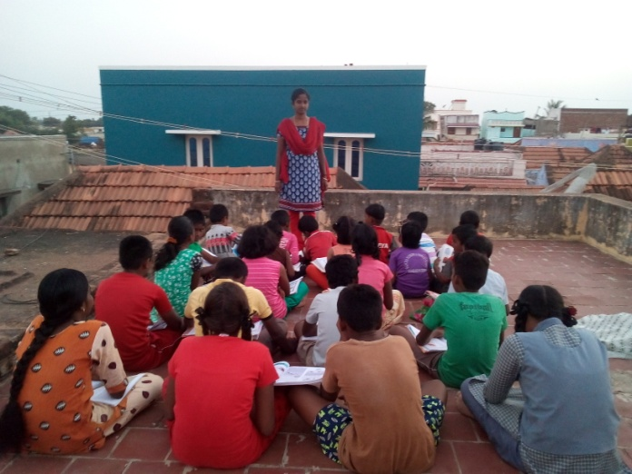
With the support of SIVA Trust, supplementary education centres functioned at five villages, viz., Vanniconendal, M.N. Nallur, Achampatti, Kurukkalpatti and Meenthulli, in which a total of 168 (93 boys + 75 girls) school going children are getting additional input on educational subjects daily for about 2 hours in the evenings. The coaching in these centres by local volunteers has improved their academic status to an appreciable level. Regular class tests are conducted to improve their performance in school tests. Pongal festival was celebrated in all the centres during January.
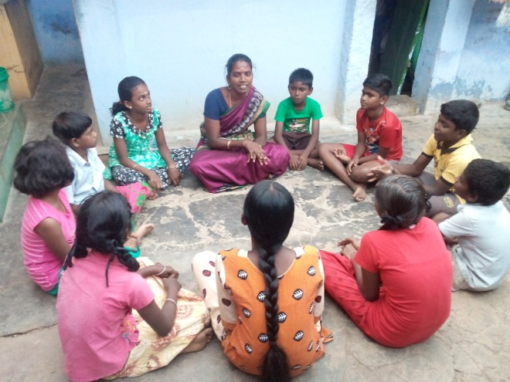
Children’s club meetings:
Meetings were conducted in all the 15 villages under our coverage in January, February and March (82 boys + 75 girls = 157 each month). Discussions were on importance of education, school enrolment, child rights, child labour, fear of exam, self respect, features of POCSO Act, evils of child marriage, book reading habit, preventing drop out, minimum use of cell phone, and about e-learning methods being introduced.
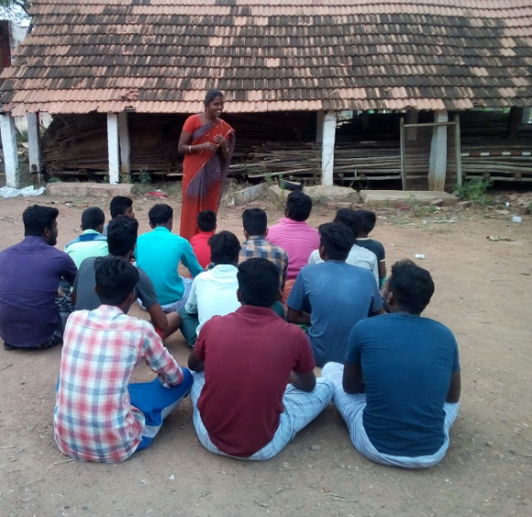
Youth Club activities:
Youth club meetings were conducted by the Education Motivator when the youth were asked to work for the goals of SIVA Trust, in their respective areas, to stop child labour, child marriage, to keep the village clean and healthy. They were also told about the available employment opportunities. A total of 90 boys attended the January meetings at 6 centres, 108 at 6 centres in February and 42 at 3 centres in March and they assured to work along with the Trust.

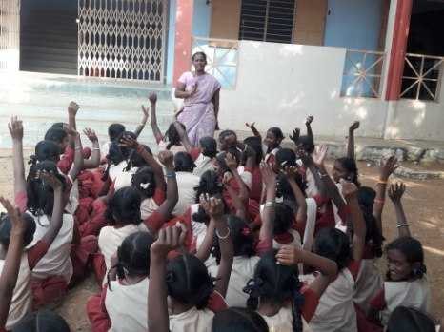
Adolescent girls meeting:
The Health worker conducted adolescent girls meetings in five villages (72) during January, 5 (118) in February and in 5 villages in March (67), when she explained the 5 goals of SIVA Trust and urged them to work for those goals in their villages. Besides, they were told about self hygiene, menstrual cleanliness, opposing child marriage and child labour etc. They were also told about POCSO Act.
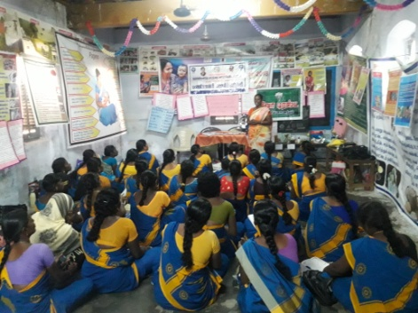
Training to Anganwadi staff:
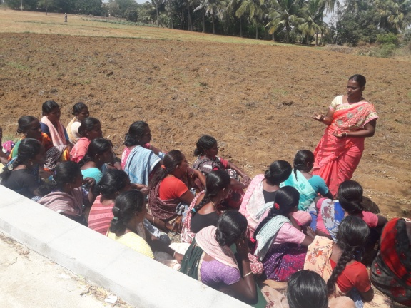
The Trust staff used the occasion of monthly meeting (53) of Anganwadi staff at Sankarankovil in the month of February to tell them about methods to prevent anaemic conditions, avoiding low weight child birth, maintaining height – weight normality of adolescent girls and consumption of healthy and nutrient food.
ANC/PNC Counselling:
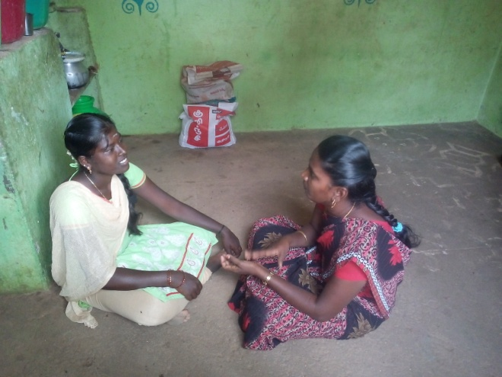
The Health Worker conducted counselling sessions to the ante-natal / post-natal mothers in 5 villages during January (67), 5 (66) in February and in 5 (60) in March and took counselling on safe delivery, maintaining good health of mother and child, personal hygiene, intake of nutritious meals etc.
Regular counselling to affected children:
Regular counselling on importance of education and need for economic improvement continued to the 6 identified affected children by the Trust staff.
Assistance to Persons with Disability:
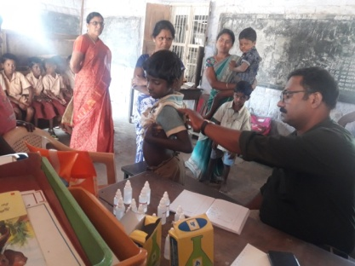
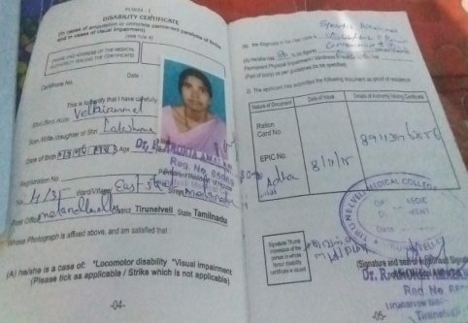
SIVA Trust staff started focussed work for around 100 persons with disability in 4 villages in Melaneelithanallur and Manur blocks. The staff was engaged in getting the persons with disability the National Disability ID card, pension, aids & appliances, rail/bus pass and other Government schemes available, by interacting with the Tirunelveli District Differently abled Rehabilitation Officer. During the quarter, 8 persons got ID card and 6 persons got rail/bus travel pass. Besides, 10 applications have been submitted seeking rail/bus pass. The earlier submitted other applications of PwDs have also been pursued regularly. One deaf and dumb woman of Vanniconendal was helped in getting free sewing machine from Govt, for her livelihood.
With the help of a homeo doctor from Kerala, homeo medical assistance was provided free of cost to 15 persons with disability, including 3 MR children, for various ailments during the month of January. Follow up treatment was given to 11 and 3 new cases were taken care of in February.

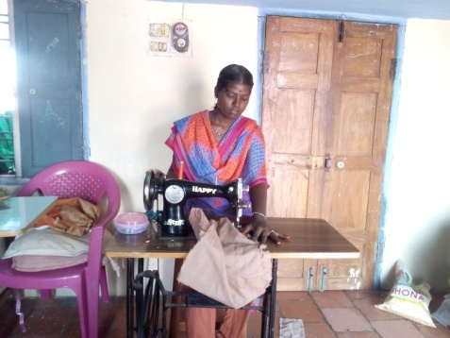
One mild mentally retarded, 17-years old girl of Koovachipatti, who had studied up to 8th Std. and was doing cooli work for 4 years was counselled to undergo vocational skill training for her sustenance and was admitted in the tailoring class conducted by the Trust at Vanniconendal.
Awareness meetings on disability:
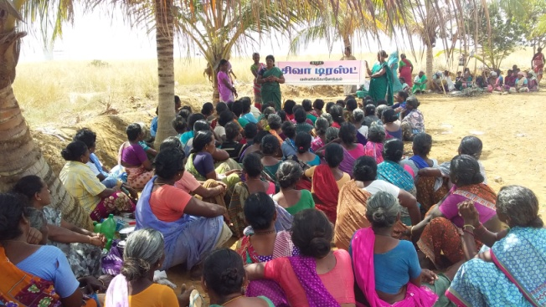
Awareness meetings were conducted in the month of January, in Kuppanapuram (39) and in Periyakovilankulam (42) villages, at Seethakurichi (94) in February and in 3 villages (66) during March, explaining the various services undertaken by the Trust for the welfare of persons with disability and also for the protection of child rights
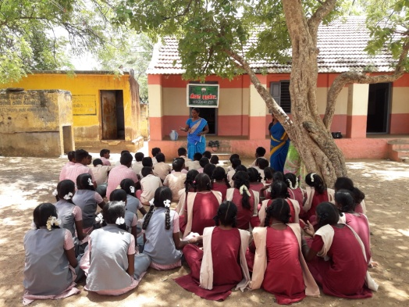
School Awareness meetings:
Our Education Promoter conducted awareness programs to school students at 5 schools (408) during the month of March, when they were given advice not to become cell phone crazy, to prevent child marriage, child labour, dropping out from schools etc.
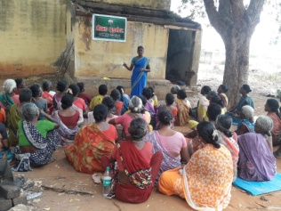
Public Health Awareness meetings:
The Health Worker organised awareness meetings on public health issues in 6 villages (207) during March, when she explained the evils of diabetes, need to consume more water during summer months, intake of nutritious food and regular counselling to the children.
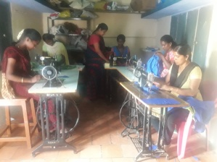
Vocational training:
In the tailoring institute functioning at Vanniconendal, 100 girls and women have been trained in the last 15 months. Currently 23 are undergoing training. A small function was held in March to distribute certificates to 25 trainees and also to give away prizes to those who won in the competitions held.
Gram Sabha meetings on January 26th:
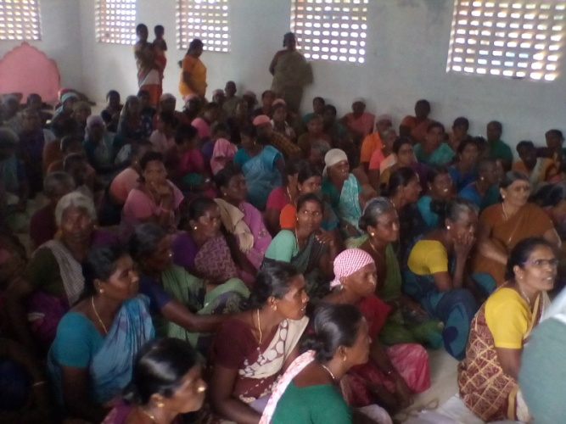
The SHG members and public in our working area were motivated to utilise the occasion of Gram Sabha meetings on January 26th, to raise their demand for infrastructure facilities. Thus the members and our staff took part in the Gram Sabha meetings in the panchayats of Melaneelithanallur, Periyakovilankulam and Vanniconendal and raised demands for better sanitation, drinking water supply, adequate number of street lights, MGNRGES jobs for more days, prevention of child marriage and more assistance to the persons with disability.

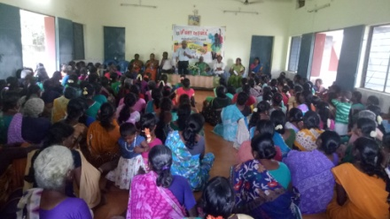
Women’s Day celebrations:
SIVA Trust organised Women’s Day celebrations on March 8th at Thirumalapuram, in which more than 210 women SHG members participated. While SIVA Trust Managing Trustee S.S.Shiva greeted the women on that occasion, State level Health Trainer Rajam spoke on the importance of toilet use and ICDS Supervisor Annammal spoke on women and child health. The members presented song and dance programs and prizes were distributed.

***********

