SIVA Trust activities report of TdH-NL program for the third quarter of 2018
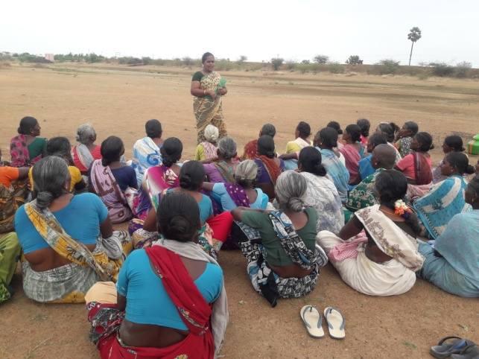
SHG members training:
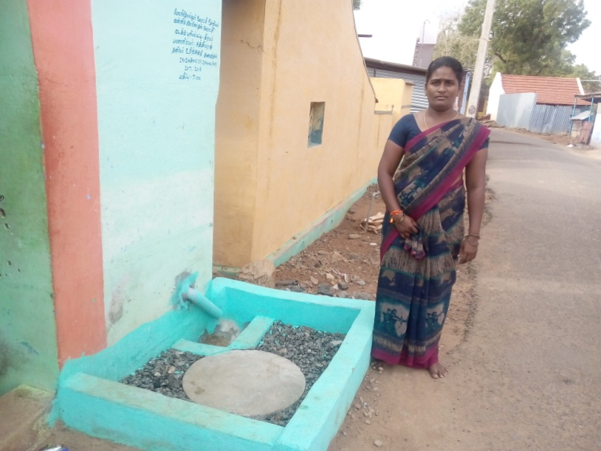
SIVA Trust organised training for SHG members at 3 centres in July (103 members), in 4 centres (136) in August and in 4 centres (165) in September, in which Community Organisers Hemima, Umabathy and Pramachi trained the members on gender equality, self respect, problem solving, decision making, and handling stress and emotions. They also explained the activities of SIVA Trust and appealed the members to stop child abuse, child marriage and Child labour and also the five targets fixed by the Trust for its 25th year, viz., 1) All villagers should be child labour-free; 2) No child marriage; 3) No delivery in home; 4) All villages should be clean from sanitation point of view and 5) All houses should have lavatories used by the family. Focus was made on life insurance, crop insurance and cattle insurance and also using the Gram Sabha meetings to achieve the demands of the villages. Special focus was given on clean village campaign. They were also told to avail the vocational training facilities in computer and tailoring provided by SIVA Trust to improve their skill.
Supplementary Centres:
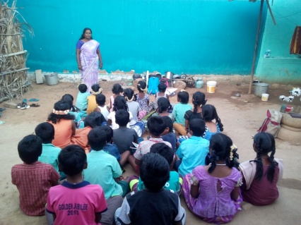
With the support of SIVA Trust, supplementary education centres functioned at six villages, viz., Vanniconendal, Thirumalapuram, Achampatti, Kurukkalpatti, Devarkulam and Meenthulli, in which a total of 180 (100 boys + 80 girls) school going children are getting additional input on educational subjects daily for about 2 hours in the evenings. The coaching in these centres by local volunteers has improved their academic status to an appreciable level. Regular class tests are conducted to improve their performance in school tests. The centre at Thirumalapuram was closed in August and in that place, a new centre was opened in M.N. Nallur. The total strength by the end of the quarter went up to 189 (99 boys + 90 girls)
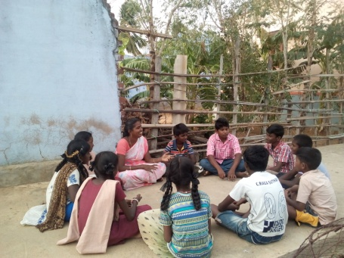
Children’s club meetings:
Meetings were conducted in all the 15 villages under our coverage in July, August and September (82 boys + 75 girls = 157 each month). Discussions were on importance of education, school enrolment, child rights, child labour, fear of exam, self respect, child line number etc., controlling emotions, coping with mental stress, decision making and on solving problems through life skill education gaining general knowledge by reading newspapers and non-curricular books.
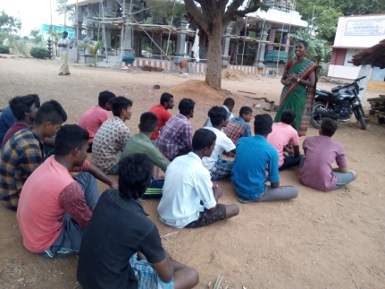
Youth Club activities:
Youth club meetings were conducted by the Education Motivator when the youth were asked to work for the goals of SIVA Trust, in their respective areas, to stop child labour, child marriage, to keep the village clean and healthy. They should play a role in changing the society for the better. A total of 56 boys attended the July meetings, 47 in August and 67 in September and they assured to work along with the Trust.
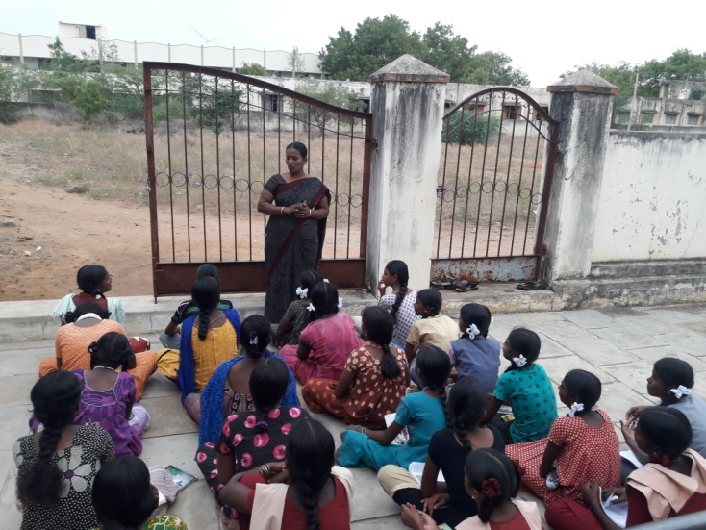
Adolescent girls meeting:
The Health worker conducted adolescent girls meetings in five villages (78) during July, 5 (59) in August and in 5 villages in September (94), when she explained the 5 goals of SIVA Trust and urged them to work for those goals in their villages. Besides, they were told about self hygiene, menstrual cleanliness, opposing child marriage and child labour etc.
Training to Anganwadi staff:
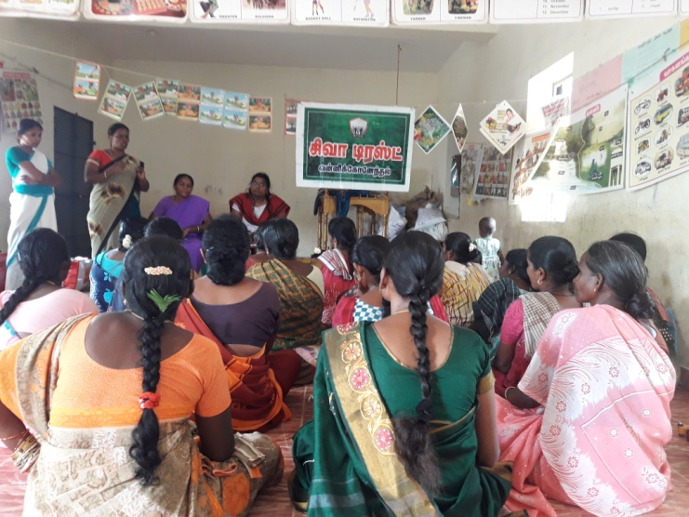
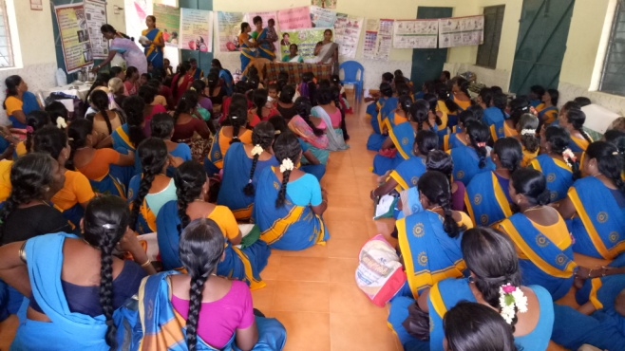
In the Melaneelithanallur block level monthly meeting for Anganwadi staff conducted at Thirumalapuram on August 6th, Community Organisers Hemima, Umabathy and Health Worker Murugeswari explained the activities of SIVA Trust in the area and trained the staff on breast feeding of children. A total of 90 persons including Anganwadi staff and pregnant mothers attended the session.
ANC/PNC Counselling:
The Health Worker conducted counselling sessions to the ante-natal / post-natal mothers in 5 villages during July (73), 5 (76) in August and in 5 (120) in September and took counselling on safe delivery, maintaining good health of mother and child, personal hygiene, intake of nutritious meals etc.
Regular counselling to affected children:
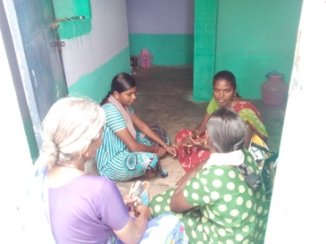
During April 2017, 21 affected / drop out children were identified in 20 families in our working villages. Out of them, 12 could be re-schooled and continuous counselling on education and health issues were given to them by our staff. Two other children migrated from their villages along with their family. For the remaining 7 children, counselling and motivation to pursue education continues, but they continue to assist their family chores only because of the poor condition of the family.

Assistance to Persons with Disability:
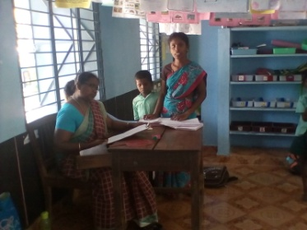
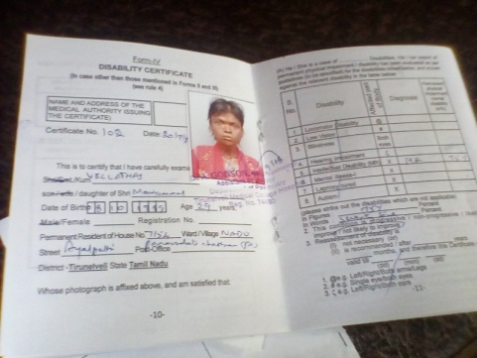
SIVA Trust staff located more than 300 persons and children with disabilities in the 15 working villages and took up a special fund raising campaign to help them, in the month of June, by joining the Global Giving / Impact Guru Accelerator programme and mobilised donation worth more than USD 5,000 for the project. The fund reached by the end of July, after which the work started in full swing in both Melaneelithanallur and Manur blocks. The staffs were engaged in getting the persons with disability the National Disability ID card, pension and other Government schemes available, by interacting with the Tirunelveli District Differently abled Rehabilitation Officer. In 6 villages, 43 PwD were identified, their requirements assessed and they were being helped. Till September, one person got ID card, one drop out child got school re-admission, one person got voter’s ID and 11 applications have been submitted seeking assistive devices.
POCSO Awareness to girl students:
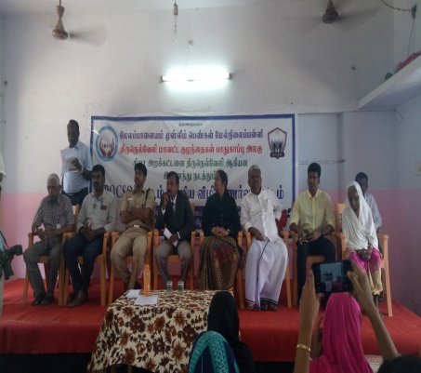
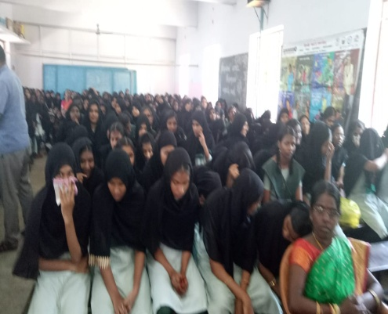
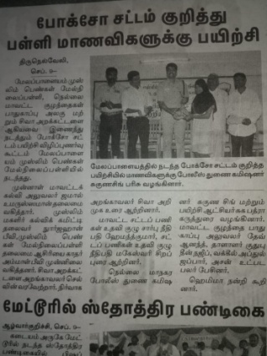
A programme was organised jointly by SIVA Trust and Tirunelveli District Child Protection Unit for orienting the girl students of Melapalayam Muslim Girls Higher Secondary School on September 4th. More than 600 girl students and teachers of the school were benefitted by the program. While SIVA Trust Managing Trustee Mr. S.S.Shiva introduced the subject, Judges Hemand Kumar and Maheswary, Trainee Collector Sugabatra, Dy Commissioner of Police Suguna Singh, DCPO Dev Anand, Advocate Abdul Jabbar, senior journalist T.S.M.O.Hassan and school correspondent Qutbuddin Najeeb spoke on the subject elaborately and advised the students on the steps to be taken to safeguard themselves from physical, verbal electronic harassment with sexual intonations.

