SIVA Trust activities report of TdH-NL program for the second quarter of 2018
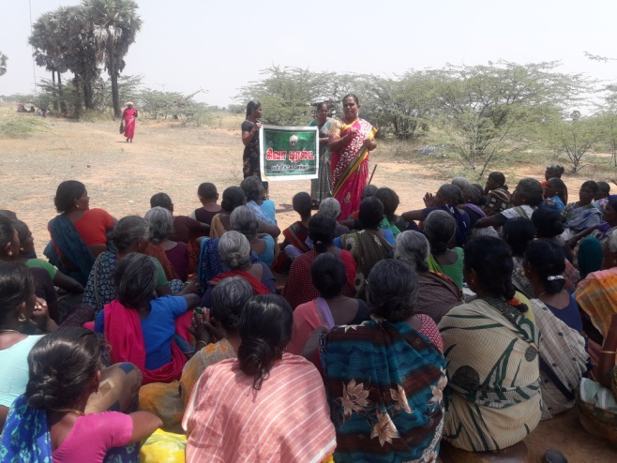
SHG members training:
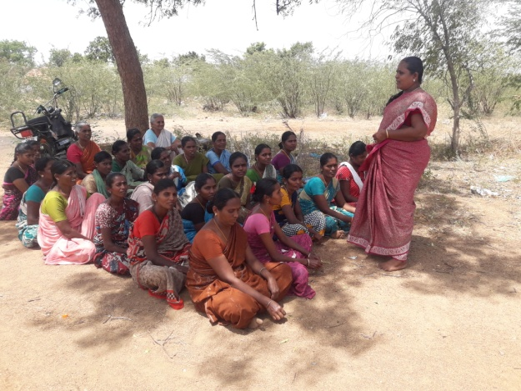
SIVA Trust organised training for SHG members in Meenthulli village on 28th April, in which a total of 71 members took part. Community Organiser Umabathy trained the members on gender equality, self respect, problem solving, decision making, and handling stress and emotions. They also explained the activities of SIVA Trust and appealed the members to stop child abuse, child marriage and Child labour and also the five targets fixed by the Trust for its 25th year, viz., 1) All villagers should be child labour-free; 2) No child marriage; 3) No delivery in home; 4) All villages should be clean from sanitation point of view and 5) All houses should have lavatories used by the family. Focus was made on life insurance, crop insurance and cattle insurance and also using the Gram Sabha meetings to achieve the demands of the villages.
Special training focussing on clean village campaign were organised in 4 villages during the month of June, attended by 117 women SHG members in total. They were also told to avail the vocational training facilities in computer and tailoring provided by SIVA Trust to improve their skill.
Supplementary Centres:
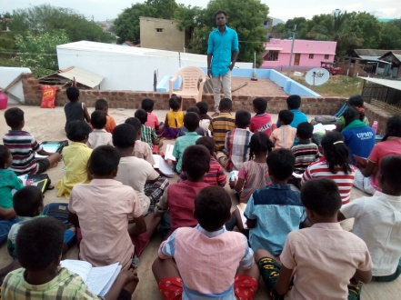
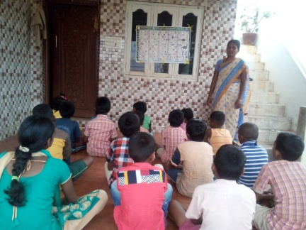
With the support of SIVA Trust, supplementary education centres functioned at six villages, viz., Vanniconendal, Thirumalapuram, Achampatti, Kurukkalpatti, Devarkulam and Meenthulli, in which a total of 167 (95 boys + 72 girls) school going children are getting additional input on educational subjects daily for about 2 hours in the evenings. The coaching in these centres by local volunteers has improved their academic status to an appreciable level. Regular class tests are conducted to improve their performance in school tests. Special coaching was given in April because of the ongoing exams.
The second anniversary of the supplementary centre at Vanniconendal was celebrated on May 3, by organising competitions in elocution, singing and games for the children as well as the members of women SHGs in the area and the winners were given prizes. Rajeshkumar of Dharmathurani and the tuition centre in-charge Karthik organised the program. Inspector Thomas of Devarkulam P.S. and the Community Organisers of SIVA Trust spoke on the occasion.

Children’s club meetings:
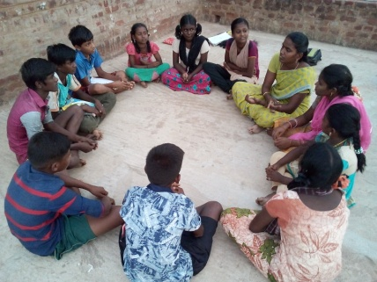
Meetings were conducted in all the 15 villages under our coverage in April, May and June (82 boys + 75 girls = 157 each month). Discussions were on importance of education, school enrolment, child rights, child labour, fear of exam, self respect, child line number etc., controlling emotions, coping with mental stress, decision making and on solving problems through life skill education gaining general knowledge by reading newspapers and non-curricular books.
Youth Club activities:
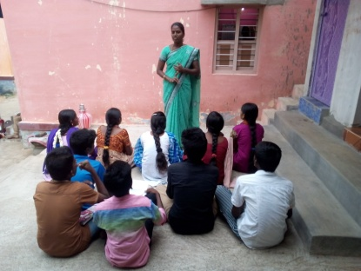
New youth clubs were formed in Vanniconendal, Periyakovilankulam and Vadakku Puliampatti during the month of April and meetings were conducted by the Education Motivator in April, May and June, when the youth were asked to work for the goals of SIVA Trust, in their respective areas, to stop child labour, child marriage, to keep the village clean and healthy. They should play a role in changing the society for the better. A total of 30 (15 boys + 15 girls) attended the first month’s meetings and they assured to work along with the Trust. The youth strength went up to 100 by June.
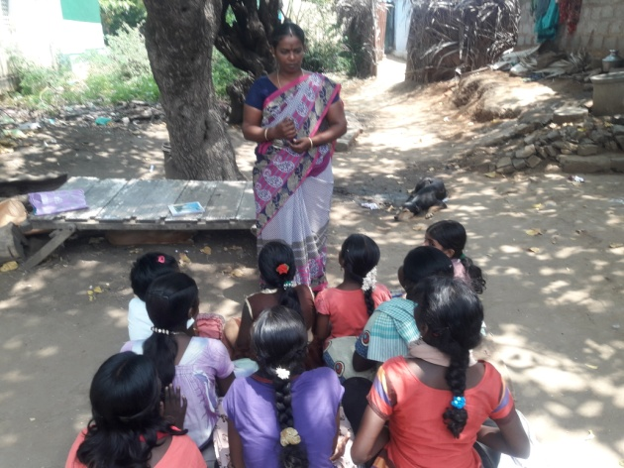
Adolescent girls meeting:
The Health worker conducted adolescent girls meetings (17) in two villages during April, 4 meetings (40) in May and 4 meetings in June (81), when she explained the 5 goals of SIVA Trust and urged them to work for those goals in their villages. Besides, they were told about self hygiene, menstrual cleanliness, opposing child marriage and child labour etc.
Training to Anganwadi staff:
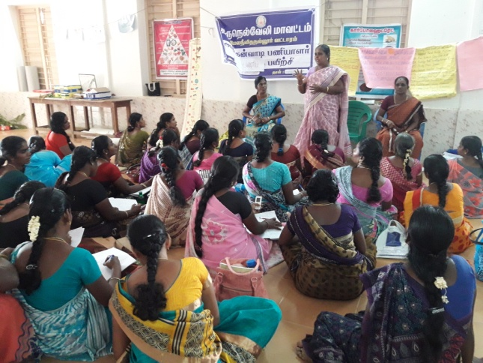
In the Melaneelithanallur block level monthly meeting (37) for Anganwadi staff conducted in the P.U. Office, M.N. Nallur on April 30, Community Organiser Umabathy and Health Worker Murugeswari explained the activities of SIVA Trust in the area and trained the staff on child rights, child abuse etc. and requested their support in achieving the five goals set by the Trust for its silver jubilee year. It was also assured to train the staff on new things during every monthly meeting for the better running of the Anganwadis in the block.

Summer camp for children:
To engage the children in our contact usefully during the summer vacation, a camp was organised for two days in our working village, Thirumalapuram on May 14 & 15, 2018. The Managing Trustee Mr. S.S.Shiva took part on the first day and the Finance Trustee Mr. T. Selwyn was present on the second day and interacted with the cildren. All the other staff including the tuition teachers were presented on both the days and facilitated the camp. A total of 83 boys and 94 girls took part. Anbalagan of Meenthulli taught them on various rural traditional arts, while Allidurai and Karikalan taught them 7 types of yogasan. The children enjoyed the two-day event.
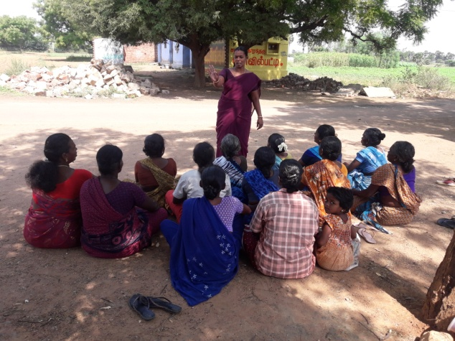
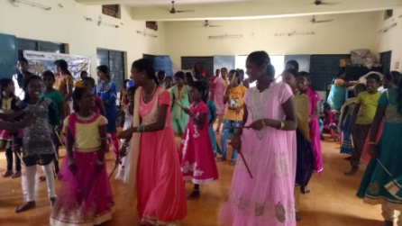
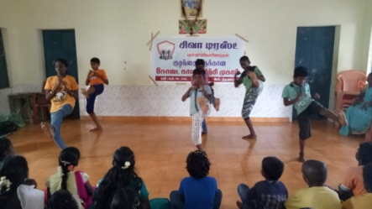
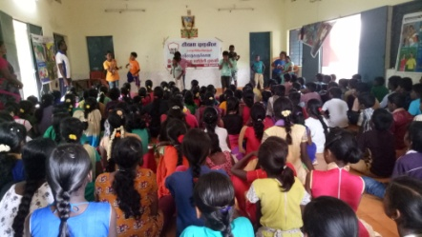
Public Health Awareness meeting:
SIVA Trust Health Worker Murugeswari conducted public health awareness meeting in 2 villages (22) during the month of April and 3 in May (57), in which the people were benefitted with additional knowledge on cleanliness, contagious diseases, bad consequences of child marriage on physical and mental health of girls etc.
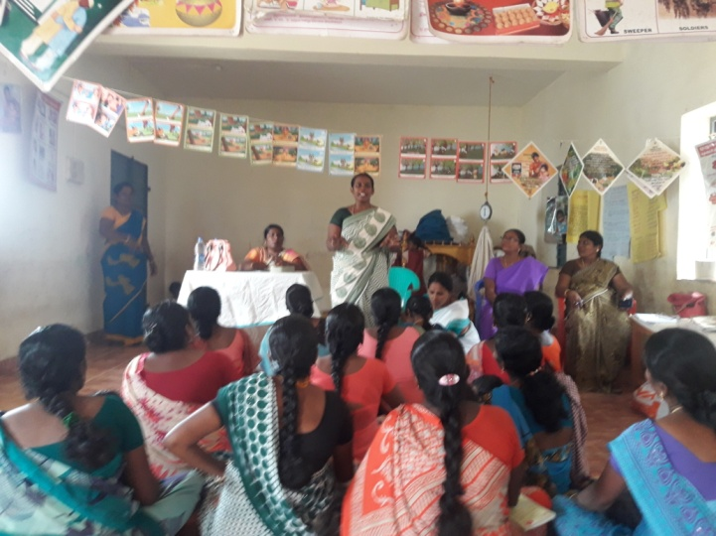
ANC/PNC Counselling:
The Health Worker conducted counselling sessions to the ante-natal / post-natal mothers in 3 villages during the month of June, in which a total of 43 mothers took counselling on safe delivery, maintaining good health of mother and child, personal hygiene, intake of nutritious meals etc.
Gram Sabha meetings on May 1:
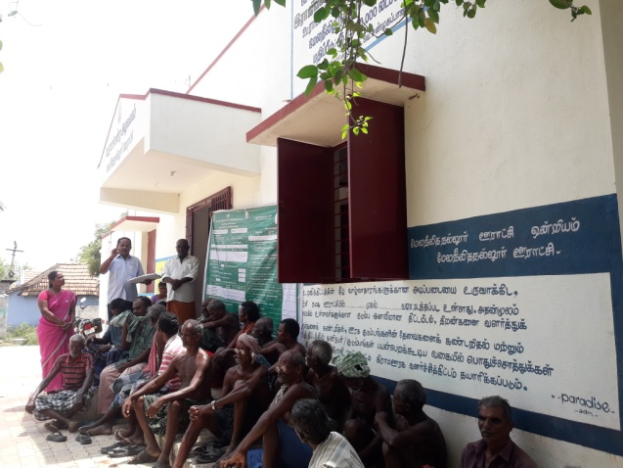
SIVA Trust staff attended the Gram Sabha meetings on May 1 at Melaneelithanallur and Periyakovilankulam, explained the activities of SIVA Trust in those villages and also the 5 goals set by the Trust for its silver jubilee year and got those goals adopted as resolutions in the meetings, for the panchayat staff to follow, with the cooperation of the public.

Regular counselling to affected children:
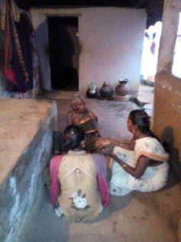
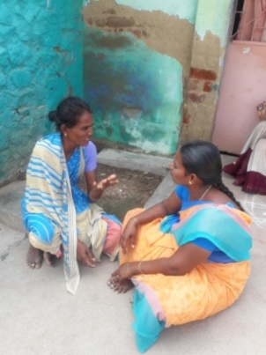
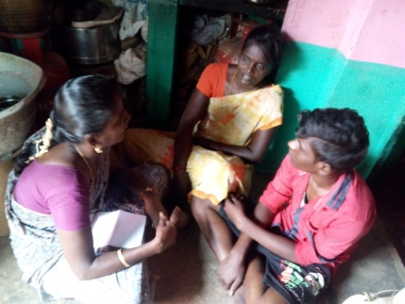
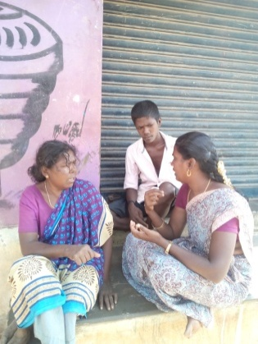
During April 2017, 21 affected / drop out children were identified in 20 families in our working villages. Out of them, 12 could be re-schooled and continuous counselling on education and health issues were given to them by our staff. Two other children migrated from their villages along with their family. For the remaining 7 children, counselling and motivation to pursue education continues, but they continue to assist their family chores only because of the poor condition of the family.
SIVA Trust Annual Day celebration:
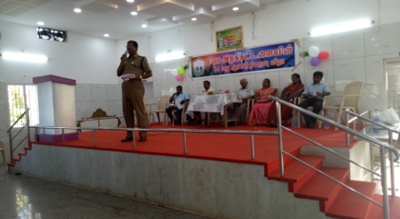
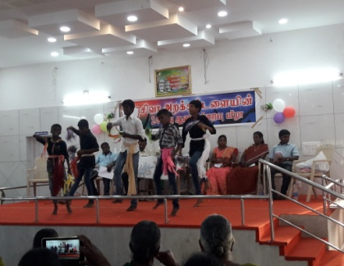
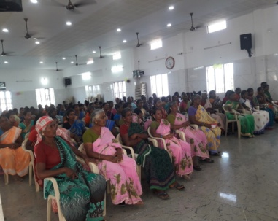
SIVA Trust celebrated its 24th year completion in a solemn function at Vanniconendal village on April 8, 2018, participated by 175 representatives of the stakeholders. In the function presided over by the Managing Trustee, Mr. S.S.Shiva, the Chief guest was Mr. P.R. Rajendran, Dy.S.P., Sankarankovil, who lauded the services of the Trust in the backward block of Melaneelithanallur and assured all support of is department to the services of the Trust. He appealed to the gathered public to stop child labour and child marriage at any cost. Teachers Rajeshkumar, Saravanan and Samy told about their association and experiences with the activities of SIVA Trust. Student representatives presented dances and maim shows. The Managing Trustee announced 5 new goals to be taken up by SIVA Trust staff in that area during the silver jubilee year.
Assistance to Persons with Disability:
SIVA Trust staff located more than 300 persons and children with disabilities in the 15 working villages and took up a special fund raising campaign to help them, in the month of June, by joining the Global Giving / Impact Guru Accelerator programme and mobilised donation worth more than USD 5,000 for the project. The fund is expected to reach by the end of July, after which the work will start in full swing. Meanwhile, the staff are engaged in getting them the National Disability ID card, pension and other Government schemes available, by interacting with the Tirunelveli District Differently abled Rehabilitation Officer.

