SIVA Trust activities report of TdH-NL program for the fourth quarter of 2018
SHG members training:
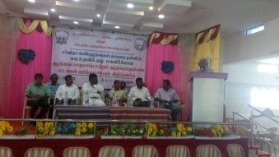
On the occasion of International Women’s Day, SIVA Trust organised training on POCSO Act and child protection for SHG members on October 10th at Vanniconendal, in which more than 340 SHG members participated. While SIVA Trust Managing Trustee S.S.Shiva introduced the subject, Judges Sornakumar, Marikkalai and Maheswary and Akiladevi, DCPO Dev Anand, Vanmuhil Britto and Thilagavathi of IRCS spoke on the subject elaborately and advised the women on the steps to be taken to safeguard their girl children from physical, verbal, electronic harassment with sexual intonations.
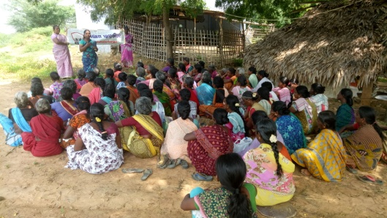
Regular training were conducted at 3 centres in October (182 members) and in 3 centres (266) in December, in which Community Organisers Hemima, Umabathy and Pramachi trained the members on gender equality, self respect, problem solving, decision making, and handling stress and emotions. They also explained the activities of SIVA Trust and appealed the members to stop child abuse, child marriage and Child labour. Focus was made on child protection, welfare of differently abled, prevention of child marriage and clean village campaign. They were also told to avail the vocational training facilities in computer and tailoring provided by SIVA Trust to improve their skill.
Supplementary Centres:
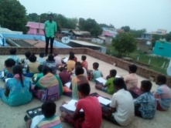
With the support of SIVA Trust, supplementary education centres functioned at six villages, viz., Vanniconendal, M.N. Nallur, Achampatti, Kurukkalpatti, Devarkulam and Meenthulli, in which a total of 193 (100 boys + 93 girls) school going children are getting additional input on educational subjects daily for about 2 hours in the evenings. The coaching in these centres by local volunteers has improved their academic status to an appreciable level. Regular class tests are conducted to improve their performance in school tests. The centre at Devarkulam did not function in December and the strength went down to 162 (90 boys + 72 girls).
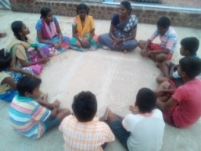
Children’s club meetings:
Meetings were conducted in all the 15 villages under our coverage in October, November and December (82 boys + 75 girls = 157 each month). Discussions were on importance of education, school enrolment, child rights, child labour, fear of exam, self respect, features of POCSO Act, evils of child marriage, book reading habit, preventing drop out, minimum use of cell phone, avoiding crackers for Deepavali and observing hand washing day on October 15th. They were motivated to learn spoken English in the e-service centre at M.N.Nallur.
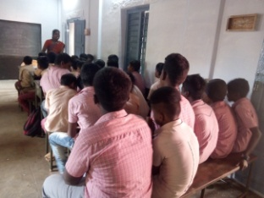
Youth Club activities:
Youth club meetings were conducted by the Education Motivator when the youth were asked to work for the goals of SIVA Trust, in their respective areas, to stop child labour, child marriage, to keep the village clean and healthy. They should play a role in changing the society for the better. A total of 63 boys attended the October meetings, 86 in November and 47 in December and they assured to work along with the Trust.
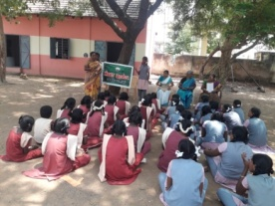
Adolescent girls meeting:
The Health worker conducted adolescent girls meetings in five villages (94) during October, 5 (73) in November and in 5 villages in December (67), when she explained the 5 goals of SIVA Trust and urged them to work for those goals in their villages. Besides, they were told about self hygiene, menstrual cleanliness, opposing child marriage and child labour etc. They were also told about POCSO Act.
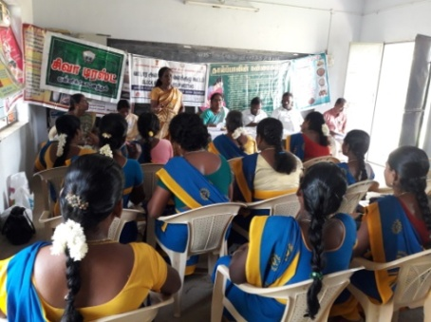
Training to Anganwadi staff:
The Trust staff used the occasion of monthly meeting of Anganwadi staff at Thirumalapuram in the month of December to tell them about methods to prevent anaemic conditions, avoiding low weight child birth, maintaining height – weight normality of adolescent girls and consumption of healthy and nutrient food.
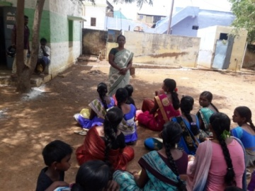
ANC/PNC Counselling:
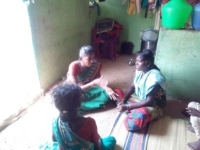
The Health Worker conducted counselling sessions to the ante-natal / post-natal mothers in 5 villages during October (63), 5 (71) in November and in 5 (60) in December and took counselling on safe delivery, maintaining good health of mother and child, personal hygiene, intake of nutritious meals etc.
Regular counselling to affected children:
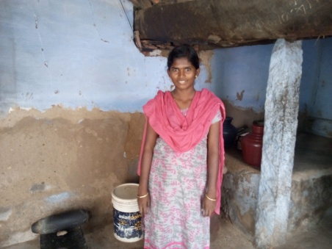
During April 2017, 21 affected / drop out children were identified in 20 families in our working villages. Out of them, 12 could be re-schooled and continuous counselling on education and health issues were given to them by our staff. Two other children migrated from their villages along with their family. For the remaining 7 children, counselling and motivation to pursue education continues, but they continue to assist their family chores only because of the poor condition of the family. One Vanmathi of Muthukrishnapuram, who was working in a nearby spinning mill was motivated to leave the job and was enrolled in the tailoring class organised by the Trust at Venniconendal.
Assistance to Persons with Disability:
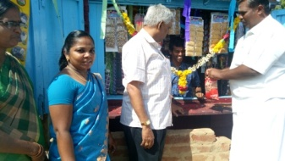
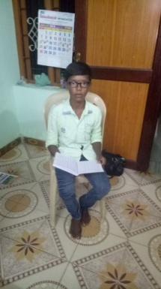
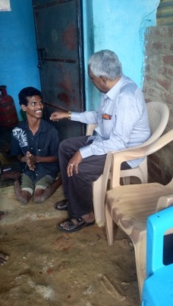
SIVA Trust staff started focussed work for around 100 persons with disability in 4 villages in Melaneelithanallur and Manur blocks. The staffs were engaged in getting the persons with disability the National Disability ID card, pension, aids & appliances, rail/bus pass and other Government schemes available, by interacting with the Tirunelveli District Differently abled Rehabilitation Officer. During the quarter, 3 persons got ID card, one got aadhar card and 2 persons got rail pass. Besides, 36 applications have been submitted seeking assistive devices, 16 seeking pension and 14 requesting rail/bus pass.
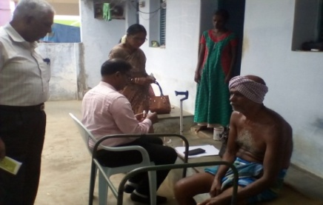
A student of Vanniconendal having low vision was helped by the Trust in procuring suitable spectacles. One crippled youth of Devarkulam was given financial assistance of Rs.20,000 to start a petty shop in his village, for his livelihood.
With the help of a homeo doctor from Kerala, homeo medical assistance was provided free of cost to 31 persons with disability, including 3 MR children, for various ailments.
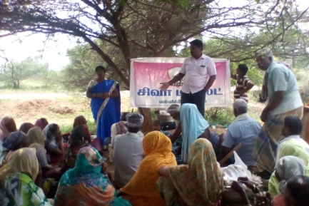
Awareness meetings o disability:
Awareness meetings were conducted in the month of November, in Dalit Girls hostel, Manur (53) and in Kurichikulam village in the same block explaining the various services undertaken by the Trust for the welfare of persons with disability and also for the protection of child rights. Similar meeting (77) was organised in Sidhankudiyiruppu in Manur block in the month of December.
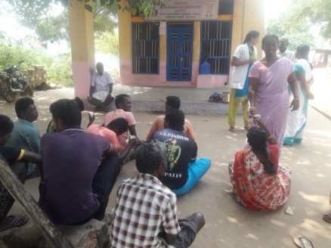
Dengue Awareness camp:
Our Health staff assisted the medical team of PHC, Kurukkalpatti in organising dengue awareness camp in the village of Aayalpatti in the month of November. In subsequent village level meetings conducted by her, she insisted on the safeguarding measures against dengue fever to all segments of society.
*********

