RF Case study:
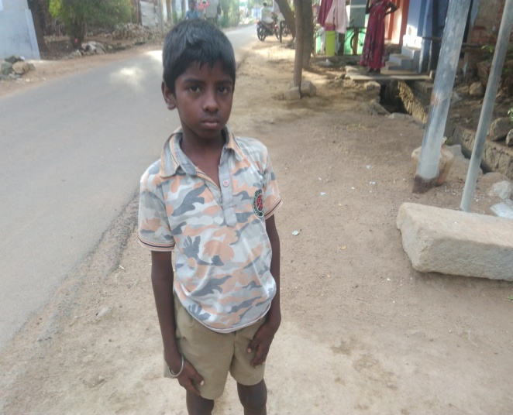
Raghavaraj (14 years), second son of Ponnusamy and Poosaithai of Yadavar Street, Meenthulli village, M.N. Nallur block, Sankarankovil taluk, Tirunelveli district is suffering from disability on his right leg. After completing 8th Standard, he lost interest in studies and slowly became a vagabond and addicted to drugs. His parents do carpentry work and all his 3 siblings regularly go to school. He was identified by SIVA Trust staff and was given homeo treatment to keep himself away from drug abuse. Simultaneously he was counselled on the importance of education for his future life. As a result, he agreed to continue education and he was helped in getting admission in 9th Standard this year in Govt. Boys High School, Kalugumalai. He is now regularly going to school, as a day scholar. His parents expressed their gratitude to SIVA Trust for getting him the homeo treatment and also for infusing interest in him on education.

